
SIMATS ENGINEERING
Saveetha Institute of Medical and Technical Sciences
Chennai-602105

AQUAGUARD 360: INTELLIGENT WATER QUALITY MONITORING AND PREDICTIVE CONTAMINATION ALERT SYSTEM

S ROOPAN RAJ(192525474)
B.Tech AI&ML

DECLARATION

I hereby declare that the project entitled "AquaGuard 360: Intelligent Water Quality Monitoring and Predictive Contamination Alert System" submitted in partial fulfillment of the requirements for the award of the degree of Bachelor of Engineering in Artificial Intelligence and Machine Learning is a record of original work carried out by me under the guidance of Dr. ANITADAVAMANI, Department of Artificial Intelligence and Machine Learning, Saveetha Engineering College.
I further declare that this project has not previously formed the basis for the award of any degree, diploma, associate ship, fellowship, or any other similar title in any University or Institution.

Date: 6/08/2026 Signature of the Student
Place: Chennai S. ROOPAN RAJ

ACKNOWLEDGEMENT
I express my sincere gratitude to Saveetha Engineering College, Chennai, for providing an excellent academic environment and the necessary facilities to carry out this project successfully.
I extend my heartfelt thanks to the Principal of Saveetha Engineering College for providing continuous encouragement, motivation, and institutional support throughout the completion of this project.
I express my sincere gratitude to the Head of the Department of Artificial Intelligence and Machine Learning for providing valuable guidance, encouragement, and the necessary infrastructure required for the successful completion of this work.
I am deeply indebted to my project guide, Dr. ANITADAVAMANI, for their constant encouragement, technical expertise, valuable suggestions, and continuous supervision throughout every stage of this project. Their guidance played a vital role in shaping this work into its present form.
I also thank all the faculty members of the Department of Artificial Intelligence and Machine Learning for sharing their knowledge and extending their support whenever required.
Finally, I express my heartfelt gratitude to my parents, family members, friends, and classmates for their unwavering encouragement, motivation, and moral support throughout the development of this project.

1. INTRODUCTION
Water is one of the most valuable natural resources and is essential for human health, agriculture, industries, and environmental sustainability. Maintaining water quality has become increasingly challenging due to industrial pollution, agricultural runoff, sewage discharge, and climate change. Traditional water quality monitoring relies mainly on manual sampling and laboratory testing, which often causes delays in detecting contamination. During these delays, polluted water may continue to be distributed, creating risks for both human health and the environment.
AquaGuard 360 is an intelligent water quality monitoring and predictive contamination alert system designed to overcome these limitations. The project combines Internet of Things (IoT), Artificial Intelligence (AI), Cloud Computing, and Machine Learning (ML) to continuously monitor water quality in real time. IoT sensors installed at different water sources measure important parameters such as pH, turbidity, temperature, dissolved oxygen, conductivity, and contaminant levels. The collected data is transmitted to a cloud platform where it is securely stored and analyzed.
Machine learning algorithms process both real-time and historical sensor data to identify abnormal patterns and predict contamination before it becomes severe. Whenever unsafe conditions are detected, the system immediately generates alerts for water authorities, allowing preventive action to be taken. The platform also provides dashboards, reports, and historical trend analysis for effective monitoring and decision-making.
The project is developed using modern software engineering practices. Source code is managed through Git, application deployment is simplified using Docker containers, and the repository is organized into modular components to improve maintainability and collaborative development.

2. PROBLEM OVERVIEW
The primary objective of AquaGuard 360 is to develop an intelligent monitoring platform capable of continuously analyzing water quality across multiple locations. Conventional monitoring methods depend heavily on periodic laboratory analysis, making early contamination detection difficult. This project replaces manual monitoring with automated IoT-based sensing and predictive analytics.
The implemented solution receives sensor data continuously, validates incoming measurements, stores them in a centralized database, and performs AI-based analysis to identify contamination risks. Authorized users access the system through a web dashboard where they can monitor live sensor values, historical trends, and active alerts.
The project also emphasizes maintainable software architecture. Source code is divided into independent modules such as backend services, frontend interface, AI prediction models, database management, Docker configuration, and documentation. This modular structure simplifies future enhancements and allows multiple developers to contribute efficiently.
The major objectives of AquaGuard 360 include:
- Continuous monitoring of water quality.
- Prediction of contamination using AI algorithms.
- Centralized storage of historical sensor information.
- Real-time alert generation.
- Interactive monitoring dashboard.
- Scalable software architecture.
- Collaborative software development using Git.
- Portable deployment using Docker.

3. KEY FUNCTIONALITIES
The AquaGuard 360 application provides several core functionalities that together form a complete intelligent monitoring platform.
User Management
The system authenticates registered users and provides secure role-based access. Administrators manage system configurations while operators monitor water quality information.
IoT Sensor Monitoring
Sensors continuously collect water quality measurements from multiple monitoring locations. These measurements are automatically transmitted to the backend server.
AI-Based Prediction
Machine learning models analyze sensor readings to identify abnormal behaviour and estimate future contamination risks.
Alert Generation
Whenever unsafe water quality conditions are detected, the system generates immediate notifications to responsible authorities.
Dashboard
Authorized users access an interactive dashboard displaying live sensor values, historical graphs, prediction results, and system alerts.
Reporting
The system generates detailed reports containing monitoring history, contamination events, and prediction summaries for regulatory compliance.
The major functionalities are summarized below.
Module | Function
Authentication | User Login & Access Control
Sensor Module | Real-Time Water Monitoring
AI Engine | Contamination Prediction
Alert Module | Emergency Notifications
Dashboard | Visualization & Monitoring
Reports | Historical Analysis

4. REPOSITORY ORGANIZATION
A well-organized repository improves software maintainability, collaboration, and project scalability. AquaGuard 360 follows a modular repository structure in which related files are grouped into dedicated folders.
The backend folder contains REST APIs, business logic, database operations, and authentication services. Keeping backend logic separate from other project components simplifies maintenance and testing.
The frontend directory contains the user interface, dashboard pages, reusable components, images, and stylesheets. This separation allows frontend developers to work independently without modifying backend functionality.
The ml-model folder contains datasets, machine learning algorithms, trained models, and prediction scripts used for contamination analysis.
Docker-related configuration files are maintained inside the docker folder. This includes the Dockerfile, Docker Compose configuration, and deployment scripts.
Project documentation is maintained inside the docs directory, while screenshots and supporting images are stored separately for easier report preparation.
A modular repository reduces code duplication, simplifies navigation, and supports collaborative development through Git version control.

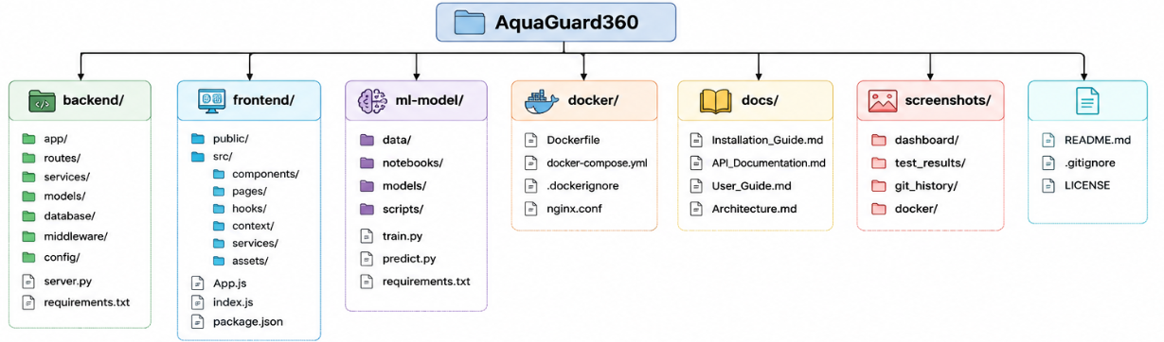

5. REPOSITORY FOLDER ORGANIZATION
Each folder in the repository has a specific responsibility, making the project easier to understand and maintain.
The backend directory contains application services such as REST APIs, database connectivity, authentication logic, and business rules. The frontend directory stores user interface components, HTML pages, JavaScript files, CSS resources, and visualization elements.
The AI module contains trained machine learning models and datasets required for contamination prediction. Docker configuration files are isolated inside a dedicated folder to simplify deployment.
Documentation files such as installation guides, project reports, and API documentation are maintained separately from source code. This organization allows developers to locate resources quickly and encourages clean project management practices.
The repository also includes configuration files such as README.md, requirements.txt, and .gitignore, which improve project documentation, dependency management, and version control.

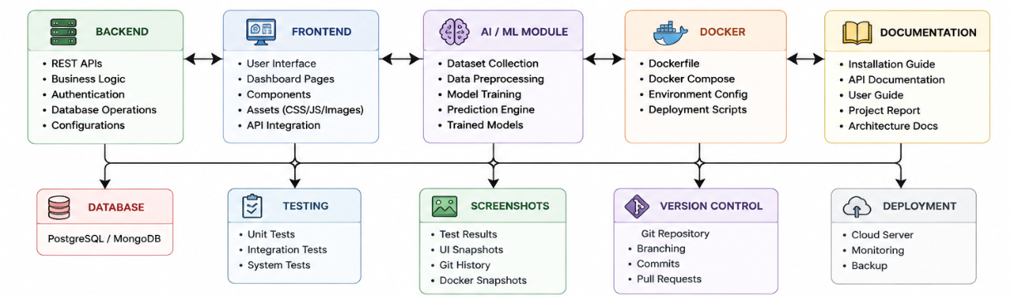

6. JUSTIFICATION OF THE REPOSITORY STRUCTURE
The repository organization adopted for AquaGuard 360 supports maintainability, readability, and collaborative software development. Developers working on the frontend, backend, AI module, or deployment scripts can modify their respective components without affecting unrelated project modules.
The modular repository also simplifies testing and debugging because each component is organized independently. Configuration files are separated from application logic, documentation is maintained centrally, and Docker resources remain isolated from source code.
This repository layout follows widely accepted software engineering practices and makes the project easier to scale as additional features such as mobile applications, GIS integration, or advanced AI models are introduced. The logical folder organization therefore supports both current development activities and future project expansion.
7. CODE QUALITY REVIEW
Code quality is one of the most important factors that determine the maintainability, reliability, and scalability of a software application. A well-written codebase allows developers to understand, modify, debug, and extend the application with minimal effort.
For AquaGuard 360, the source code is organized into independent modules such as backend services, frontend components, AI prediction models, database operations, and deployment scripts. This modular organization reduces code duplication and promotes better software architecture.
The backend follows a layered approach where API endpoints, authentication, business logic, and database operations are separated into different files. Similarly, the frontend organizes reusable user interface components separately from application pages, improving readability and maintainability.
Meaningful variable names, function names, and class names are used throughout the project. Proper indentation, consistent formatting, and descriptive comments improve code readability and make it easier for new developers to understand the implementation.
Error handling is also incorporated wherever possible to prevent unexpected application failures. Validation is performed before processing user inputs and sensor data to ensure system reliability.
Overall, the source code demonstrates good software engineering practices by maintaining clear separation of concerns, modularity, and consistency.

8. CODE READABILITY AND MODULARITY
The AquaGuard 360 project is designed using modular programming principles. Instead of placing all logic in a single source file, related functionalities are grouped into dedicated modules.
The backend contains separate files for authentication, sensor management, prediction services, database connectivity, and report generation. This separation allows developers to update one module without affecting unrelated components.
The frontend follows a component-based architecture where reusable interface elements such as dashboards, charts, navigation bars, and alert panels are developed independently.
Machine learning algorithms are also isolated inside the AI module, allowing prediction models to be updated or retrained without changing the backend API.
The following table summarizes the code organization.
Module | Responsibility
Backend | REST APIs and Business Logic
Frontend | Dashboard and User Interface
AI Module | Prediction Algorithms
Database | Sensor Data Storage
Docker | Deployment Configuration
Documentation | Project Reports and README
The modular approach significantly improves maintainability because each module performs a specific responsibility and communicates with other modules through clearly defined interfaces.

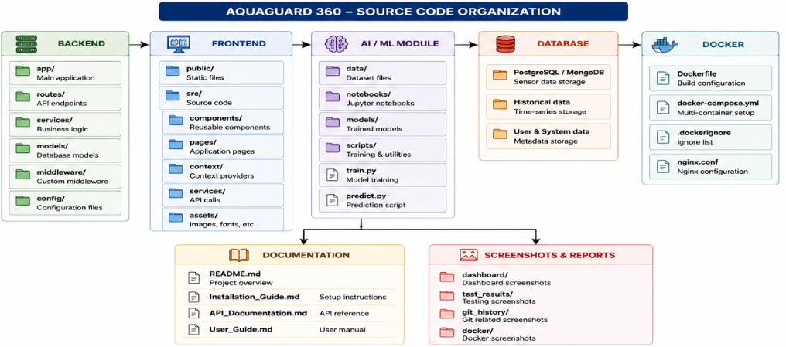

9. CODING STANDARDS AND DOCUMENTATION
The AquaGuard 360 project follows standard coding conventions to maintain consistency throughout the repository. Source files use meaningful names, proper indentation, and descriptive comments where necessary.
Functions are designed to perform single responsibilities, reducing complexity and improving readability. Repeated code is minimized by creating reusable functions and components.
Inline comments are included to explain complex algorithms such as AI-based contamination prediction. Configuration files remain separate from application logic, preventing unnecessary dependencies.
The project also includes essential documentation files such as:
- README.md
- Installation Guide
- API Documentation
- Docker Configuration
- User Guide
Maintaining comprehensive documentation helps new developers understand the project quickly and supports long-term maintenance.

Sample Code Snippet
def predict_water_quality(sensor_data):
prediction = model.predict(sensor_data)
return prediction
The above example illustrates a simple, readable function where the responsibility is clearly defined. Functions are intentionally kept short to improve understandability.

10. STRENGTHS AND AREAS FOR IMPROVEMENT
After reviewing the AquaGuard 360 source code, several strengths and possible improvements were identified.
Strengths
- Modular project architecture.
- Clean folder organization.
- Meaningful variable and function names.
- Reusable frontend components.
- Proper API separation.
- Good documentation.
- Consistent coding style.
- AI module isolated from business logic.
Areas for Improvement
Although the project follows good coding practices, additional improvements can further enhance maintainability.
More automated unit tests can be added to validate individual modules independently. Logging mechanisms can also be expanded to provide detailed debugging information.
Code coverage tools may be integrated to identify untested sections of the application. Static code analysis tools such as SonarQube or Pylint can also be incorporated to improve overall code quality.

11. VERSION CONTROL EVALUATION
Version control plays a critical role in collaborative software development. AquaGuard 360 uses Git to manage project history, coordinate multiple developers, and maintain stable software releases.
Every significant modification is recorded as a separate commit. Descriptive commit messages explain the purpose of each change, making repository history easier to understand.
Separate branches are maintained for feature development, integration, testing, and production deployment. This branching strategy reduces merge conflicts and allows developers to work independently.
The repository also maintains a clean commit history by avoiding unnecessary or duplicate commits.
The Git repository supports:
- Branch creation
- Branch merging
- Commit history
- Repository synchronization
- Version rollback
- Collaborative development

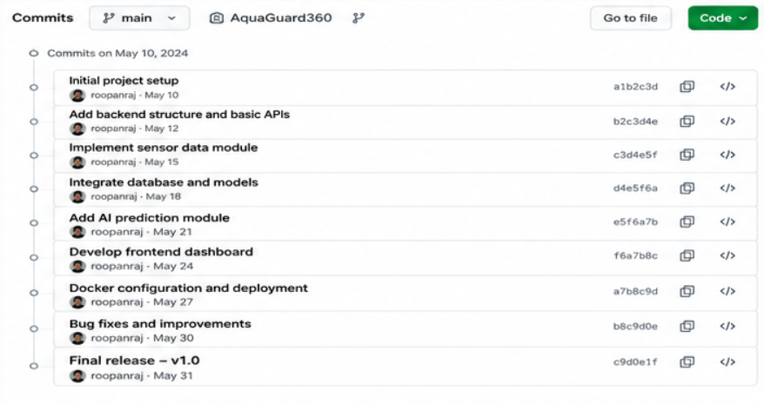

12. BRANCHING STRATEGY
The project follows a structured Git branching strategy that separates production code from ongoing development.
The Main branch always contains the stable production version of the application.
The Develop branch is used for integrating completed features before release.
Each new functionality, such as AI prediction, dashboard development, or Docker deployment, is implemented inside dedicated Feature branches. After successful testing, these branches are merged into Develop.
When a stable version is ready for deployment, a Release branch is created. Critical production issues are corrected using Hotfix branches.
The branching workflow minimizes conflicts while supporting collaborative software development.
Branch | Purpose
Main | Stable Production
Develop | Feature Integration
Feature | New Module Development
Release | Final Testing
Hotfix | Emergency Fixes

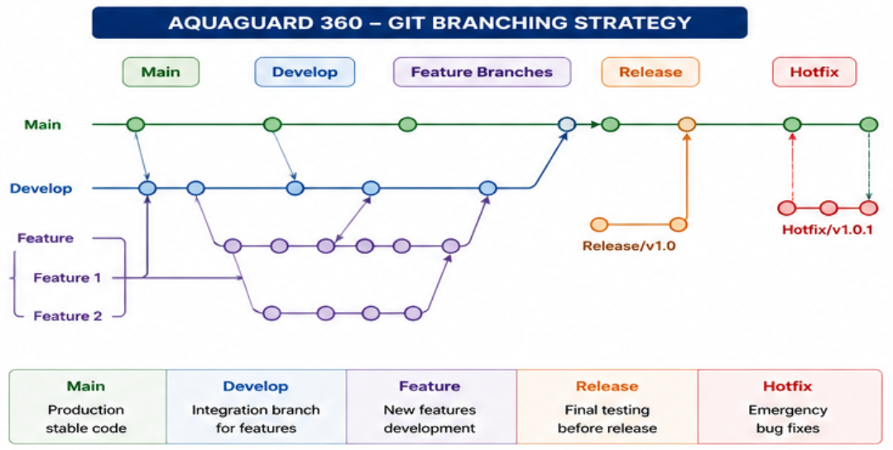

13. ROLE OF VERSION CONTROL IN COLLABORATION
Git enables multiple developers to work simultaneously on different parts of the AquaGuard 360 project without affecting each other's work. Every developer can create independent branches, implement new features, and merge them after successful testing.
The repository maintains complete version history, allowing previous project states to be restored whenever necessary. Merge requests and commit reviews also improve software quality by allowing changes to be reviewed before integration.
Remote repositories such as GitHub provide centralized storage, issue tracking, and collaborative code management, making software development more organized and efficient.
Overall, Git significantly improves project maintainability, traceability, collaboration, and software quality throughout the development lifecycle.
14. TESTING AND VALIDATION
Testing is an essential phase of software development because it verifies that every module performs its intended functionality correctly. AquaGuard 360 consists of several interconnected components including the frontend dashboard, backend REST APIs, AI prediction engine, database services, and Docker deployment. Each of these components must be tested individually as well as collectively to ensure reliable system operation.
Functional testing was carried out to verify user authentication, sensor data collection, AI-based contamination prediction, dashboard visualization, and report generation. Each function was executed using predefined test cases to confirm that the application produced the expected results.
Integration testing ensured that communication between different modules occurred correctly. The backend APIs were tested to verify successful interaction with the database, while the AI prediction module was validated using historical sensor datasets. Docker containers were also tested to ensure seamless communication between frontend, backend, AI services, and the database.
Performance testing focused on verifying that the application could process continuous sensor readings without significant delays. The system successfully handled simulated real-time sensor data while maintaining acceptable response times for dashboard updates and alert generation.
Testing confirmed that the repository structure, application logic, and deployment configuration functioned together effectively, providing a stable foundation for future enhancements.

Test Summary
Test Case | Expected Result | Status
User Login | Successful Authentication | ✅ Pass
Sensor Data Collection | Data Stored Successfully | ✅ Pass
AI Prediction | Correct Contamination Prediction | ✅ Pass
Dashboard | Display Live Sensor Data | ✅ Pass
Alert Generation | Notification Generated | ✅ Pass
Docker Deployment | Containers Running Successfully | ✅ Pass

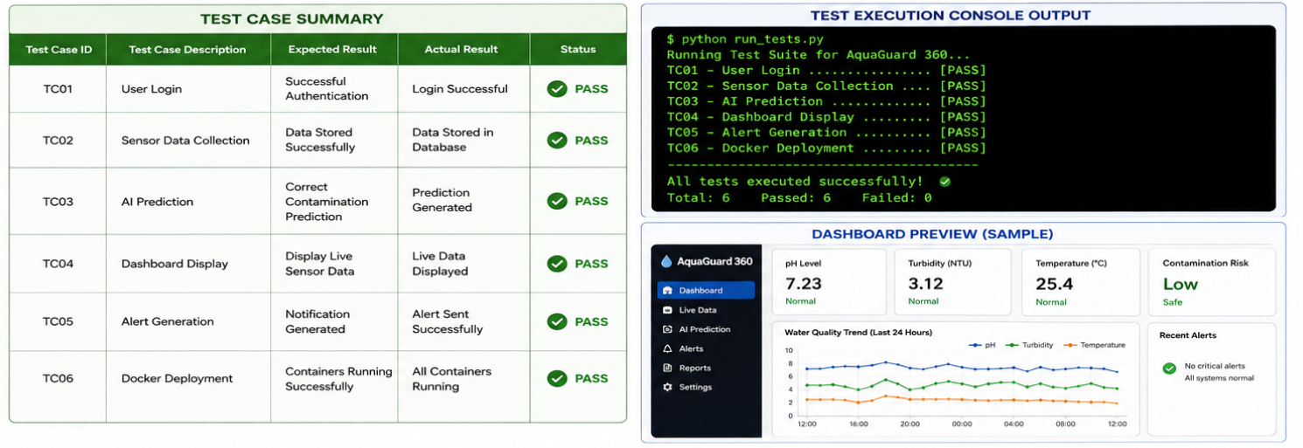

15. REPOSITORY DOCUMENTATION REVIEW
A well-maintained repository includes not only source code but also documentation that explains project setup, architecture, APIs, deployment procedures, and usage instructions.
The AquaGuard 360 repository contains a README.md file that provides an overview of the project, installation steps, required software, project objectives, and execution instructions. This file serves as the primary guide for developers who access the repository for the first time.
Additional documentation includes API descriptions, Docker deployment instructions, user guides, and project reports. These documents help developers understand the system architecture, configure the application, and troubleshoot common issues.
The documentation also explains the repository structure, making it easier to locate backend services, frontend components, AI models, configuration files, and deployment resources.
Comprehensive documentation significantly reduces onboarding time for new contributors and supports long-term software maintenance.

Documentation Included
- README.md
- Installation Guide
- API Documentation
- Docker Configuration Guide
- User Manual
- Project Report
These documents ensure that the repository remains understandable even as new developers join the project.

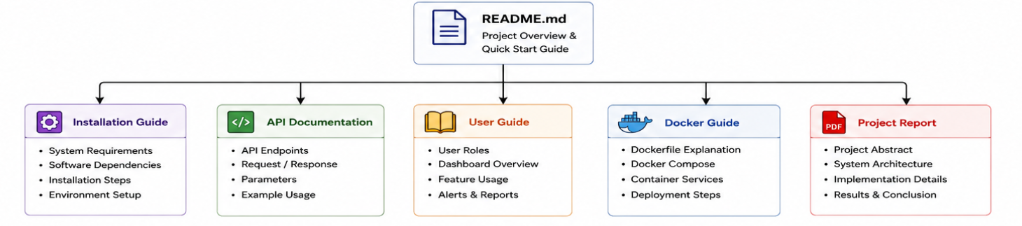

16. CODE REVIEW FINDINGS
The code review identified several strengths that contribute to the overall quality of the AquaGuard 360 project.
The repository follows a modular architecture where related functionalities are grouped into independent folders. Backend services, frontend components, AI prediction models, Docker configuration files, and documentation are clearly separated, making the project easier to maintain.
Variable names, function names, and file names are meaningful and follow consistent naming conventions. Proper indentation and formatting improve code readability, while reusable components reduce duplication across the project.
Git version control is used effectively to maintain project history and support collaborative development. Meaningful commit messages allow developers to understand previous modifications quickly.
Despite these strengths, several opportunities for improvement were identified. Automated unit testing can be expanded to increase code coverage. Static code analysis tools such as SonarQube or Pylint may also be integrated to detect potential issues during development.
Continuous Integration (CI) pipelines can be introduced to automate testing whenever new commits are pushed to the repository. Automated deployment pipelines can also simplify software releases and reduce manual configuration effort.

Strengths
- Modular repository structure.
- Clean code organization.
- Meaningful commit messages.
- Proper documentation.
- Good folder hierarchy.
- Docker support.
- Git-based collaboration.
- Maintainable architecture.
Improvements
- Increase automated testing.
- Add Continuous Integration.
- Improve code coverage.
- Introduce static code analysis.
- Expand logging and monitoring.

17. RECOMMENDATIONS
Based on the repository review, several recommendations are proposed to further improve the AquaGuard 360 project.
The repository should continue following modular development practices so that new features can be added without affecting existing components. Developers should maintain meaningful commit messages and continue using structured Git branching strategies.
Automated testing should be integrated into the repository using Continuous Integration platforms such as GitHub Actions. This will ensure that every code modification is validated before merging into the main branch.
Future versions of the project may also incorporate Kubernetes for container orchestration, enabling the application to scale efficiently across cloud environments.
Security can be further enhanced by implementing automated vulnerability scanning for Docker images and dependency analysis during every build.
Finally, repository documentation should be updated regularly to reflect software changes, ensuring that future contributors can easily understand the project structure and deployment process.

18. CONCLUSION
The repository review demonstrates that AquaGuard 360 follows good software engineering practices through the effective use of modular architecture, Git version control, Docker containerization, and comprehensive documentation.
The project repository is organized logically, making it easier to navigate, maintain, and extend. Source code follows consistent coding standards and supports collaborative development through meaningful commit history and structured branching strategies.
Testing confirms that the application functions correctly across its major modules, while Docker ensures consistent deployment across different environments. Repository documentation provides sufficient guidance for installation, configuration, and project maintenance.
Although additional automation and testing can further improve software quality, the current repository provides a strong foundation for future development. Overall, AquaGuard 360 demonstrates effective repository management, maintainable software design, and collaborative development practices suitable for real-world intelligent monitoring systems.

REFERENCES
- Git Documentation.
- GitHub Documentation.
- Docker Documentation.
- Atlassian Git Tutorials.
- Ian Sommerville, Software Engineering, 10th Edition.
- Roger S. Pressman, Software Engineering: A Practitioner's Approach, 9th Edition.
- AquaGuard 360 Project Repository Documentation.

